**Title:**

Study of Nyquist bit rate and Shannon capacity using MATLAB

**Abstract:**

This experiment is designed to-

1. To understand the use of MATLAB for solving communication engineering problems.

2.To develop understanding of Nyquist bit rate and Shannon capacity using MATLAB.

1. **Nyquist Bit Rate:** The Nyquist bit rate formula defines the theoretical maximum bit rate for a noiseless channel.

$$BitRate=2 × bandwidth × \log_{2}L$$

In this formula, bandwidth is the bandwidth of the channel, L is the number of signal levels used to represent data, and BitRate is the bit rate in bits per second.

1. **Shannon capacity:** Shannon capacity formula was introduced to determine the theoretical highest data rate for a noisy channel:

$$Capacity= bandwidth × \log_{2}(1+ SNR)$$

In this formula, bandwidth is the bandwidth of the channel, SNR is the signal-to-noise ratio, and capacity is the capacity of the channel in bits per second.

**Signal-to-noise ratio (SNR):** To find the theoretical bit rate limit, we need to know the ratio of the signal power to the noise power. The signal-to-noise ratio is defined as

$$SNR=\frac{Average Signal Power}{Average Noise Power}$$

We need to consider the average signal power and the average noise power because these may change with time.

A high SNR means the signal is less corrupted by noise; a low SNR means the signal is more corrupted by noise. Because SNR is the ratio of two powers, it is often described in decibel units,

SNRdB, defined as

$${SNR}_{dB}=10\log_{10}(SNR)$$

**Code and Output:**

1.

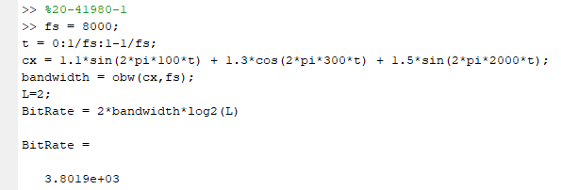

2.

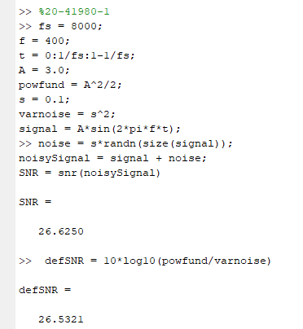

3.

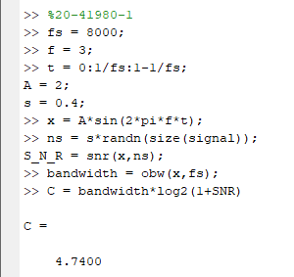

20-41980-1 (AB-CDEFG-H)

a.

A1 = (A+B+H) = 21

A2 = (B+C+H) = 5

S = (C+D+H)/30 = 6/30

b.

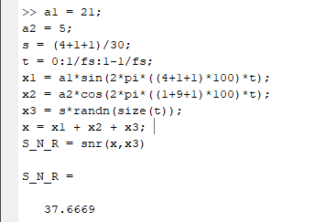

c.

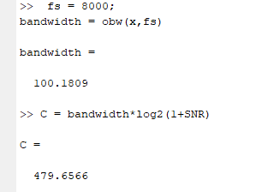

d.



20-43536-1 (AB-CDEFG-H)

a.

A1 = (A+B+H) = 21

A2 = (B+C+H) = 5

S = (C+D+H)/30 = 8/30

b.

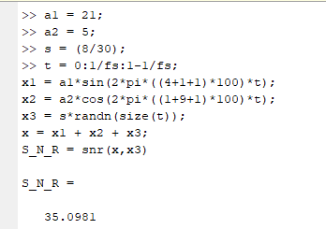

c.

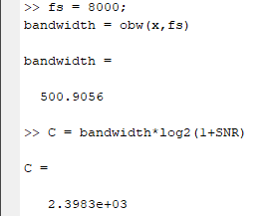

d.

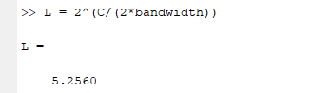

20-42999-1 (AB-CDEFG-H)

a.

A1 = (A+B+H) = 21;

A2 = (B+C+H) = 5;

S = (C+D+H)/30 = 7/30;

b.

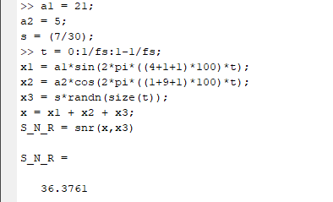

c.

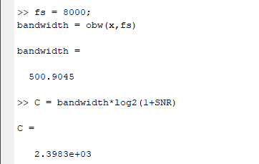

d.

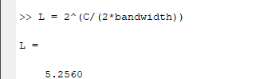

20-43513-1 (AB-CDEFG-H)

a.

A1 = (A+B+H) = 21

A2 = (B+C+H) = 5

S = (C+D+H)/30 = 8/30

b.

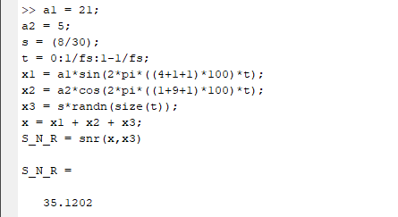

c.

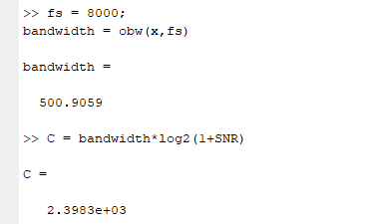

d.

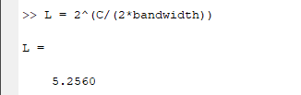

19-4160-3 (AB-CDEFG-H)

a.

A1 = (A+B+H) = 20

A2 = (B+C+H) = 14

S = (C+D+H)/30 = 6/30

b.

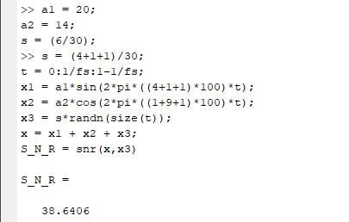

c.

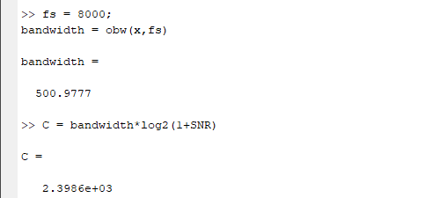

d.

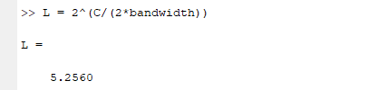

**Reference:**